**Familiar with Git commands like git init, git status, git add, git commit, git push, and git pull.**

Step 1: Setup your machine with Git Configuration

1. **To check git in your local machine**

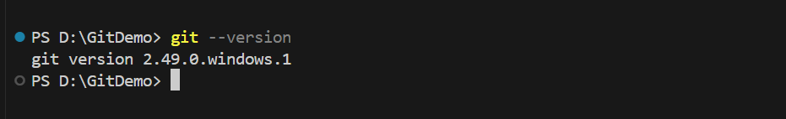

1. **To configure user level configuration**

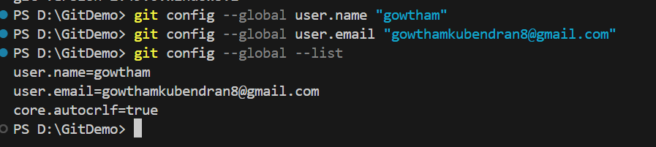

Step 2: To add a file in our local Repository

**1.To add a file in working directory**

PS D:\GitDemo> echo "This is the content of the file" > sample.txt

**2.To init a empty local repository**

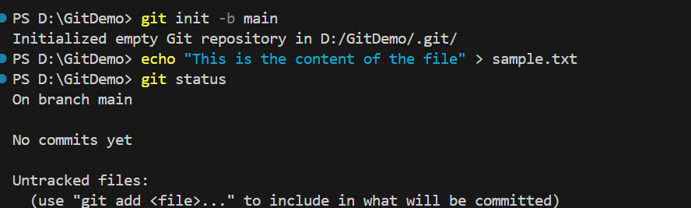

**3.Add a file to stagging area and commit it in local repo**

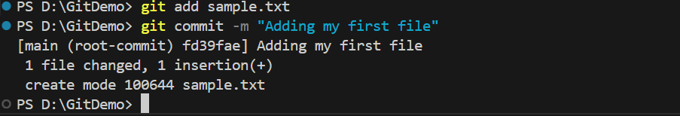

Step 3: To add a local files to remote repository

**1.To connect to remote repo**



**2.To push into remote repo**

